Project Solutions

1)Download Insurance data from the link below:

<http://www.census.gov/hhes/www/hlthins/data/utilization/tables.html>

2) Preparing Insurance file and uploading into Hue:

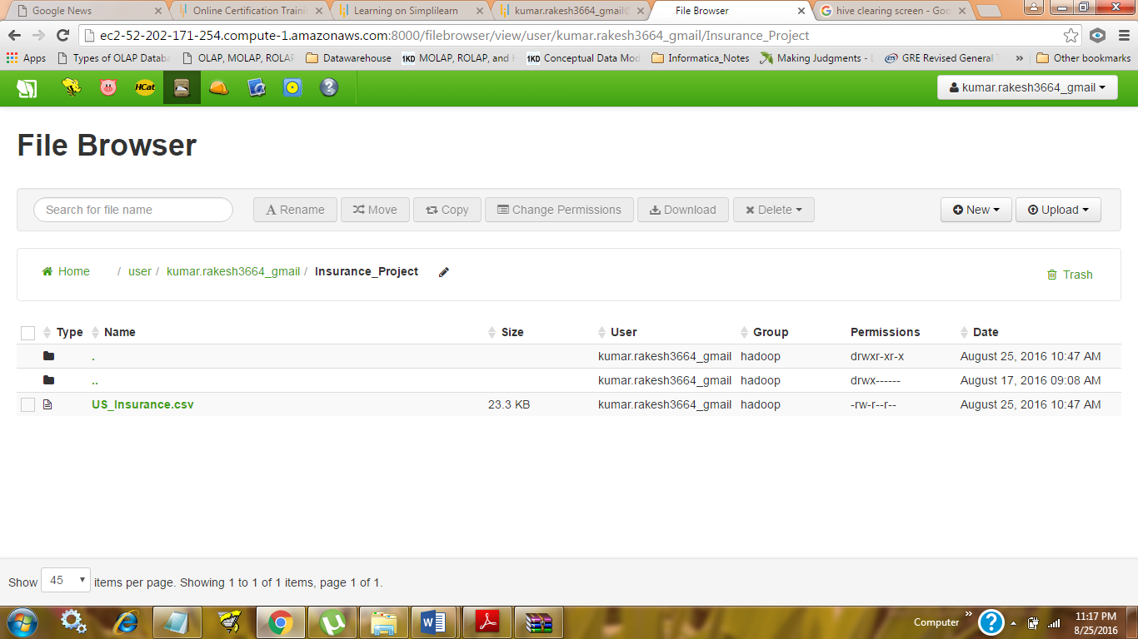

3) Creating US_Insurance_Data table:

CREATE TABLE US_Insurance_Data (Year string, Insurance_type string, Insurance_Tag String, percentage double)

row format delimited

fields terminated by ',';

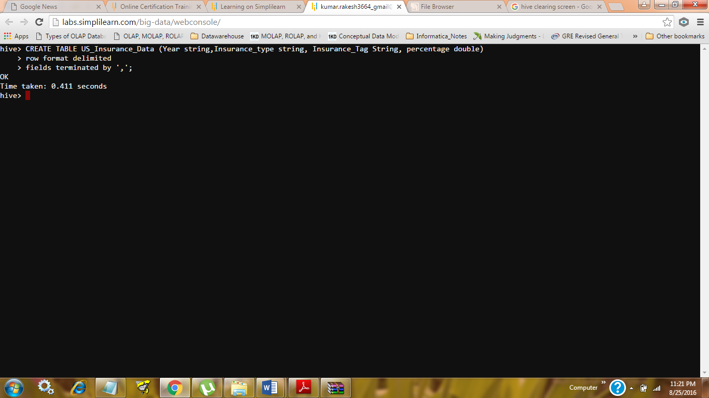

4) Loading data in US_Insurance_Data table:

LOAD DATA INPATH '/user/kumar.rakesh3664_gmail/Insurance_Project/US_Insurance.csv' OVERWRITE INTO TABLE US_Insurance_Data;

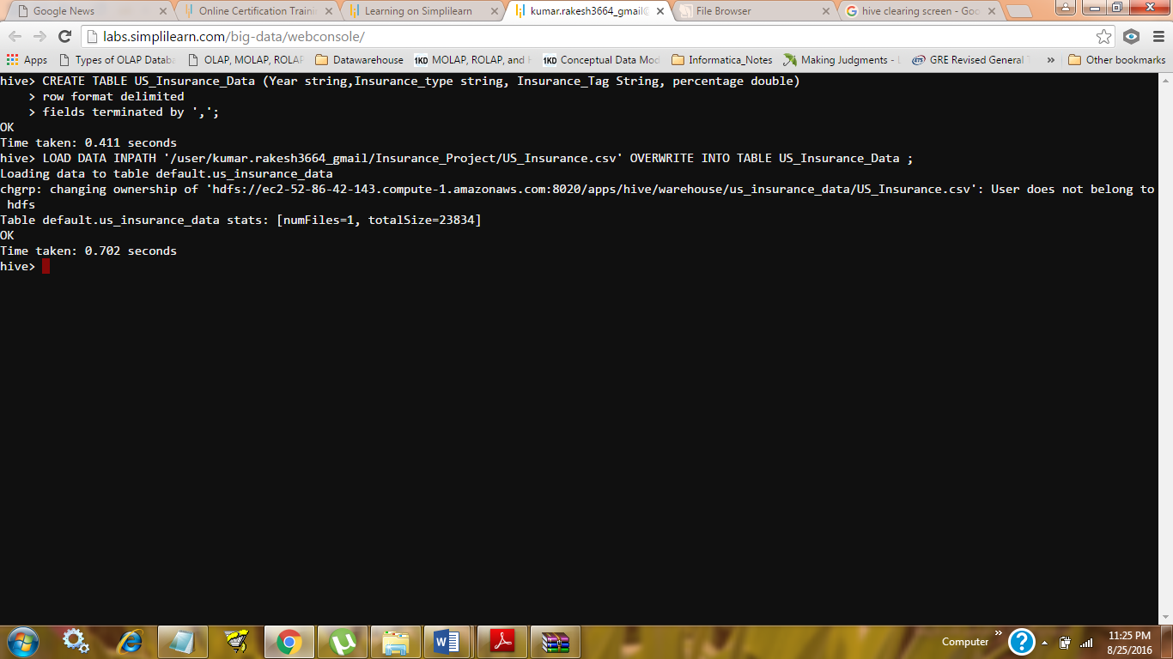

5) Hive query to find out average % of people, aged between 18 and 64, who have obtained insurance from private players from 2001 to 2011.

Select Insurance_type, Avg (percentage) as avg_prcnt from (select LTRIM (RTRIM (Insurance_type)) as Insurance_type, Insurance_Tag, percentage from US_Insurance_Data) as Ins where Insurance_Tag = 'People aged 18-64' AND Insurance_type = "..Privately insured (alone or in combination)" Group By Insurance_type;

Output:

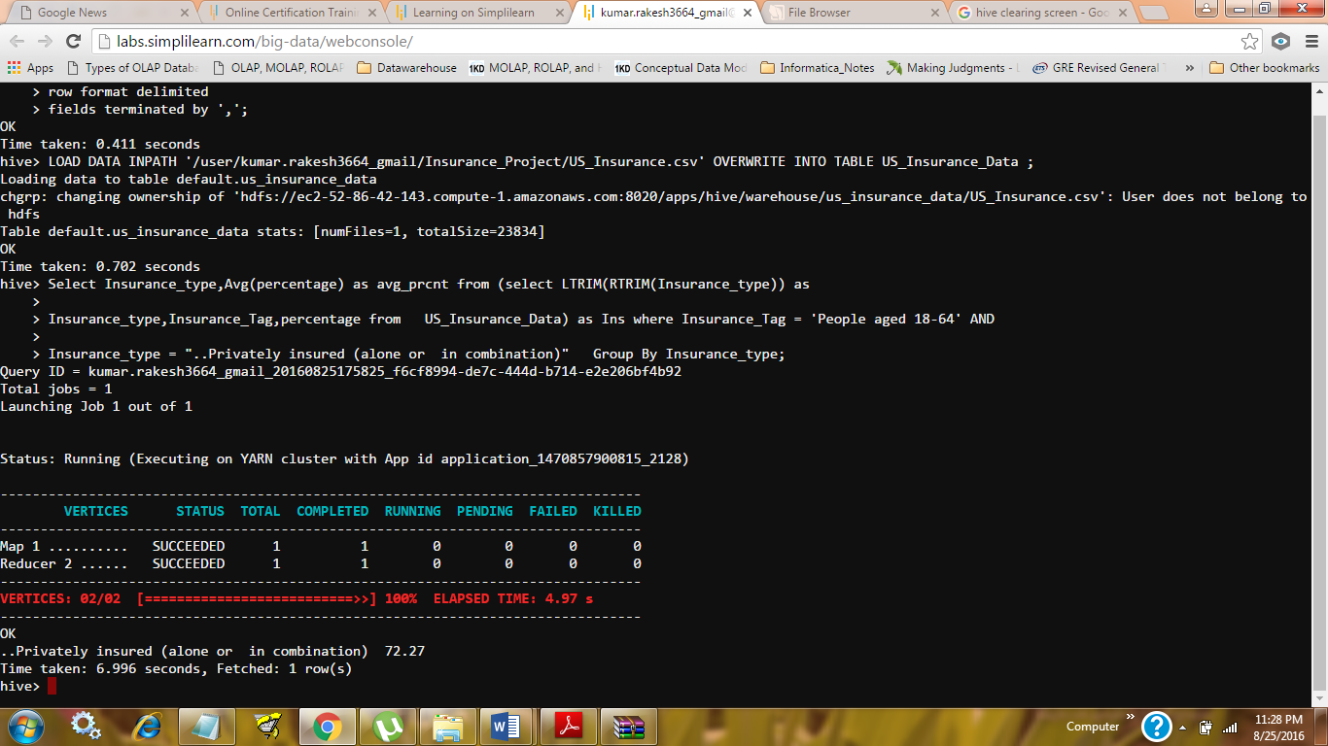

6) Hive query to find out the average percentage of people, aged 65 years or more, who are solely covered by public insurance from the year 2001 to 2011.

Select Insurance_type, Avg (percentage) as avg_prcnt from (select LTRIM (RTRIM (Insurance_type)) as

Insurance_type, Insurance_Tag, percentage from US_Insurance_Data) as Ins where Insurance_Tag = 'People aged 65 and older' AND Insurance_type = "..Publically insured (no private)" Group by Insurance_type

Output:

